**1. Main page (**[**http://canventottawa.ca)**](http://canventottawa.ca))

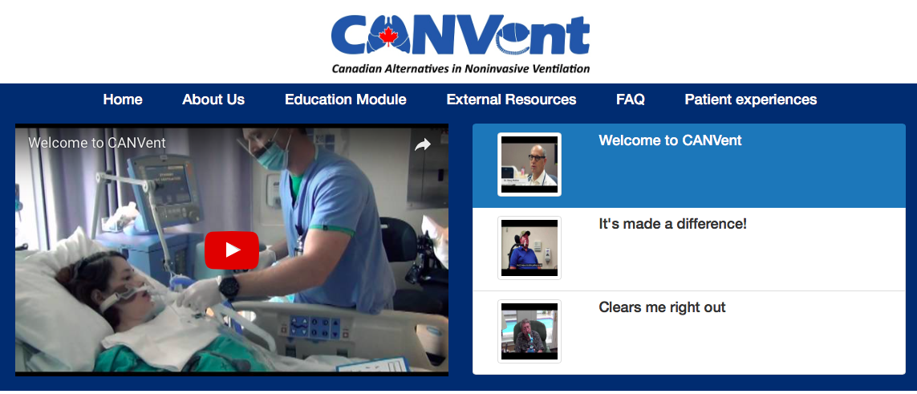

* Typos in the above screenshot
  + Patient Experiences
  + Rename “FAQ” to “Comments”
  + Clears me right out!
* Welcome to CANVent video: change the still screen to Dr.McKim (0:01)

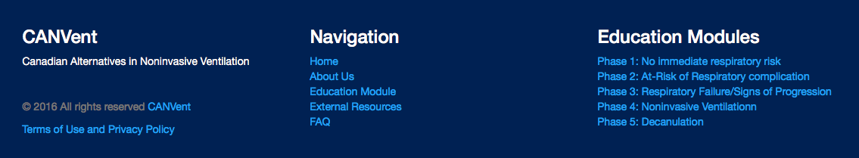

* Typos in the screenshot above:
  + Under Education Module, change to all upper case i.e. No Immediate Respiratory Risk
  + Under Navigation: rename “FAQ” to “Comments”
  + Under Navigation: add “Patient Experiences”
* Terms of Use and Privacy Policy: no content currently, please use document attached. I will let you decide whether it should be a pop up window or other format.

**2. About Us (**[**http://canventottawa.ca/About.aspx)**](http://canventottawa.ca/About.aspx))

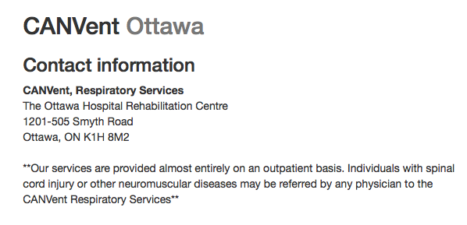

* Remove comma after CANVent: CANVent Respiratory Services

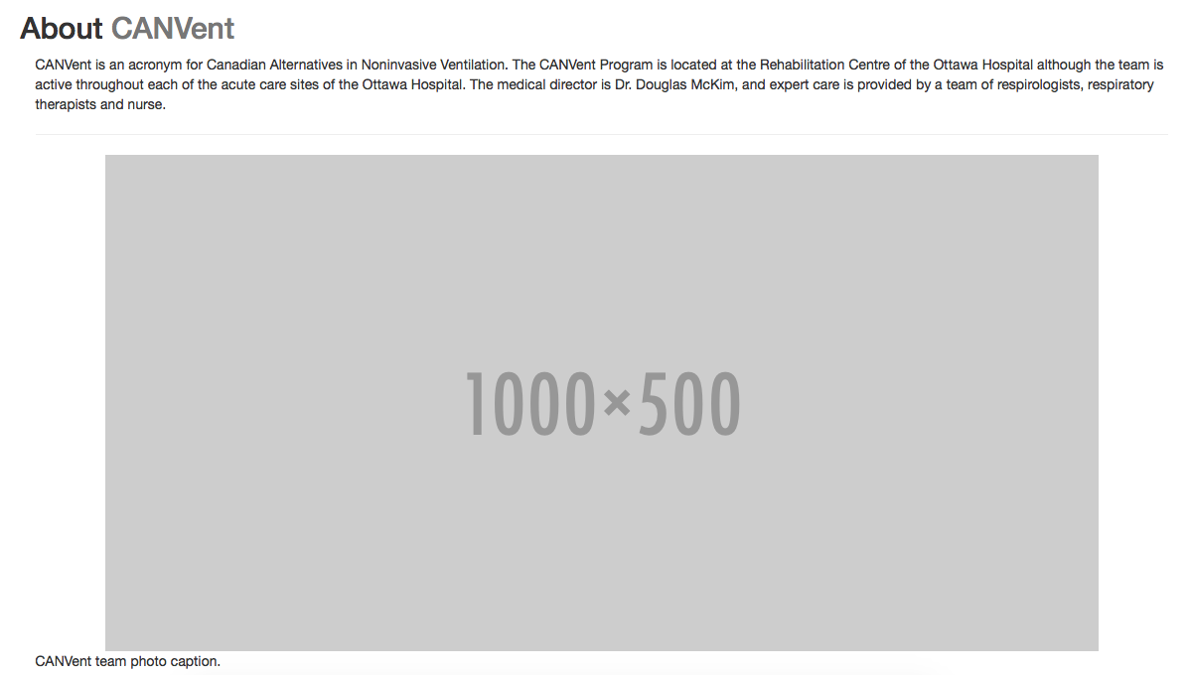

* Remove picture space holder and caption under “About CANVent”

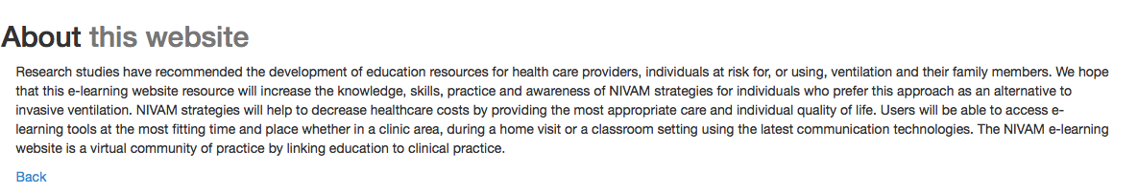

* Add team headshots below “About this website”. Refer to email Sandy sent to Mike on Feb 23,2017.

**3. External Resources (**[**http://canventottawa.ca/resources/)**](http://canventottawa.ca/resources/))

* Under 3. Networking opportunities with others living with similar conditions
  + Add “Tetra Society of North America” (<http://www.tetrasociety.org)> at the end of list
* Under 4. Other online learning resources
  + Add “myNIV” (<http://niv.mymnd.org.uk)> at the end of list
* Adjust names of 3 and 4: make them capitalized and consistent with other titles
* Discuss with Mike: Rename 2 to “Canadian Community Support” and 3 to “International Community Support”
  + Then move all Canadian websites to 2

**4. FAQ (**[**http://canventottawa.ca/FAQ.aspx)**](http://canventottawa.ca/FAQ.aspx))

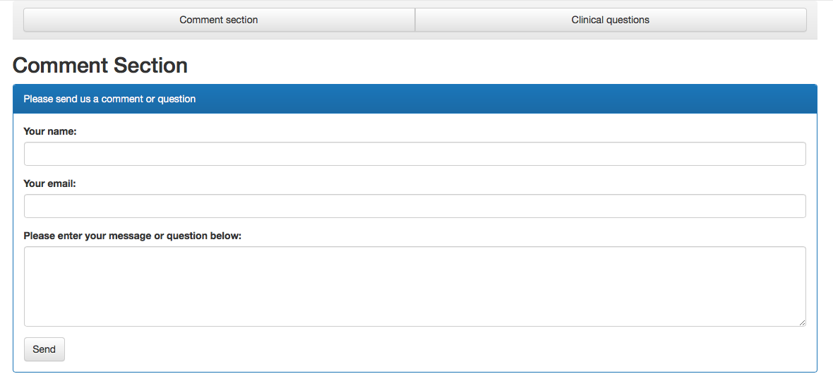

* Rename “FAQ” to “Comments” on home page ([www.canventottawa.ca)](http://www.canventottawa.ca))
* Remove “Comment section” and “Clinical questions” tabs (current content under “Clinical questions” is irrelevant)
* Remove the title “Comment Section”
* Rephrase “Please send us a comment or question” to “Please send us a comment”
* Rephrase “Please enter your message or question below” to “Message”

**5. Education Modules (**[**http://www.canventottawa.ca/nivam/overview.aspx)**](http://www.canventottawa.ca/nivam/overview.aspx))

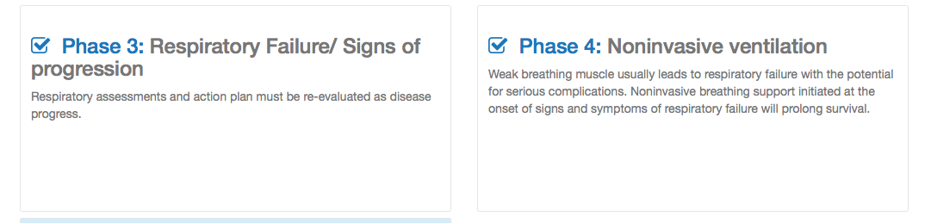

* Typos: Please adjust the following titles to make them capitalized and consistent with other titles
  + Signs of Progression
  + Noninvasive Ventilation
* “Feedback” icon at the bottom of page still has no content
  + Temporarily link to “Comments” on main page

**6. Education Module: Phase 3 (**[**http://www.ohri.ca/NIVAM/Default.aspx?SlideID=506)**](http://www.ohri.ca/NIVAM/Default.aspx?SlideID=506))



* At center top, can we remove the second title, since there’s only one presentation under this module?
* Typo: Respiratory Failture/Signs of Progression

Screen%20Shot%202017-04-06%20at%2012.12.32%20PM.png

* Is there anyways to make the question mark stands out more? i.e. different color, bigger question mark

**7. Education Module side bar menu**

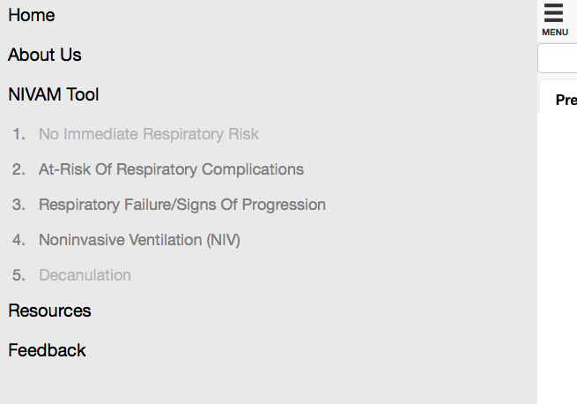

* Need same titles and links to the home page (Home, About Us, Education Module, External Resources, Comments, Patient Experiences)